My Health Care Wishes App
Brought to you by the American Bar Association
Commission on Law & Aging
Pro and Lite versions
The free Lite version is designed to store one person’s advance directive information and one document.
The Pro version at $3.99 offers these added features:
- Unlimited storage of documents and people profiles
- Email stored documents to a health care provider—be prepared in case of emergency to advocate for your loved ones, no matter where you are
- Store additional details about you and your loved ones: specialists, emergency contacts, insurance, and medical conditions
- The Personal and Family Manager allows you to show the relationships between profiles you've stored
- Click-to-call and click-to-email feature gives you an instant connection to those whose profiles you've stored
- Syncing to your DropBox account to allow for easy importing and exporting of PDF documents
- ABA multi-state power of attorney toolkit PDF for use in most states
My Health Care Wishes is a smartphone app that gives you and your family members the ability to store your own and each other’s health care advance directives, key health information, and health care contacts on your Apple or Android smartphones, and to send advance directive documents and other key information directly to health care providers by email or Bluetooth.
- More resource tips and links to help you plan smart and effectively!
What is in Resources section of the app?
The Lite version includes printable wallet cards, a blank copy of the Summary Information Sheet, and a link to the ABA health care decision resources page.
The Pro version includes printable wallet cards, a blank copy of the Summary Information Sheet, and 3 PDFs and 2 URLs related to the ABA power of attorney form, consumer toolkit, proxy guide, state-specific advance directive.
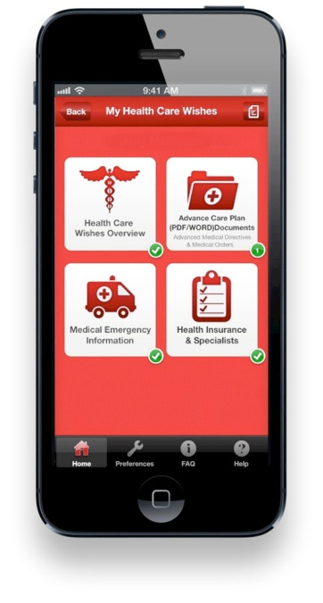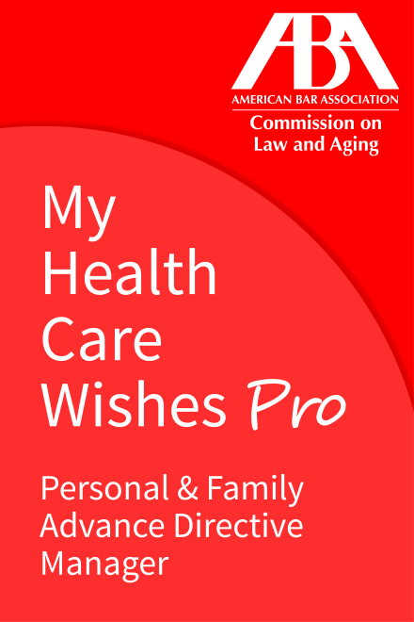

To download, go to www.MyHealthCareWishes.org

